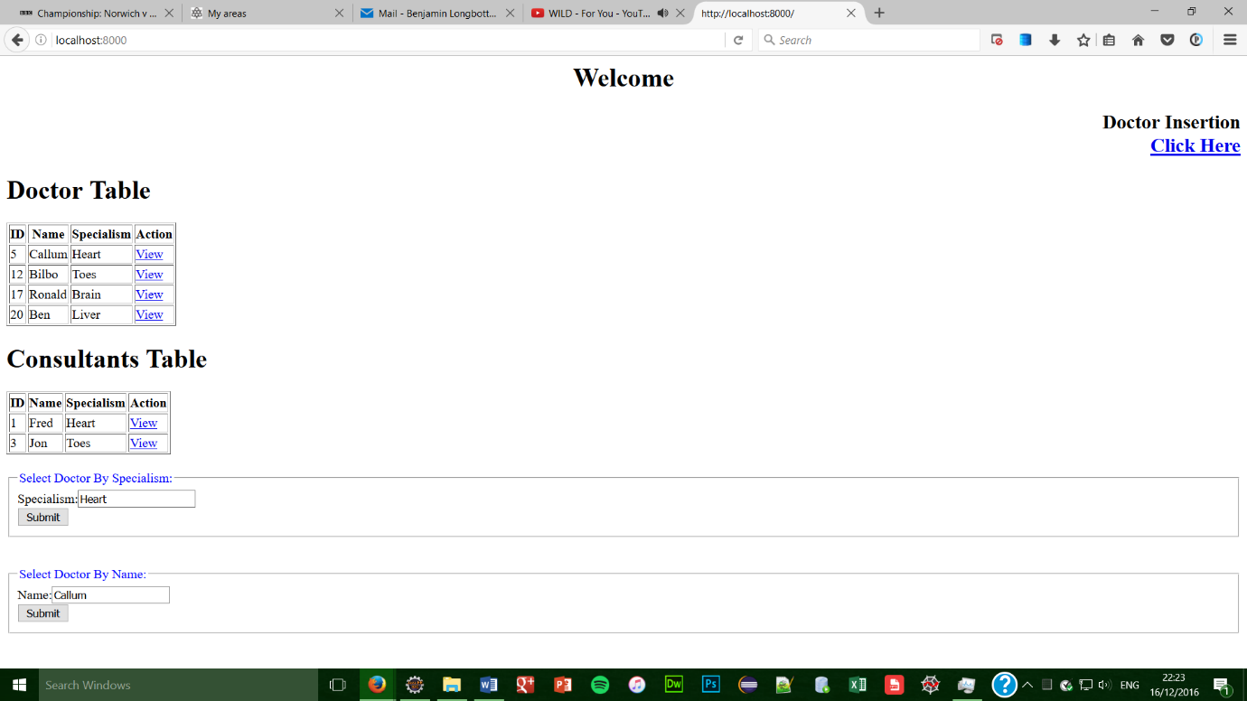Java Screenshots

localhost:8000 – This is the home page where you can select many options.

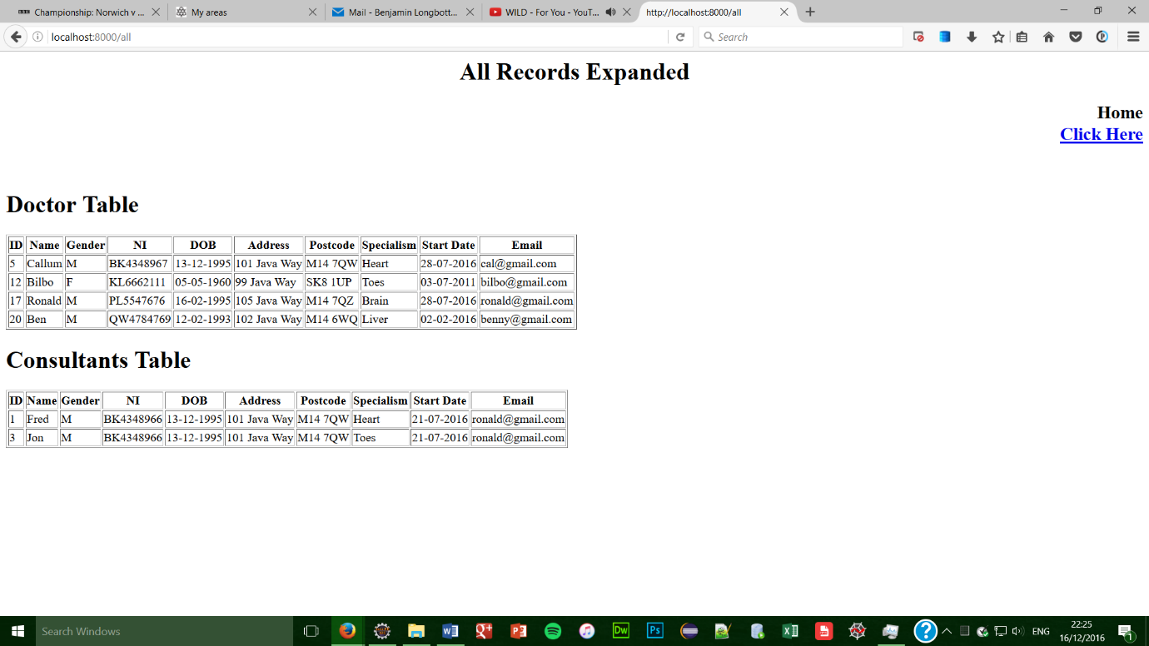

localhost:8000/all – This page displays all values of every doctor and consultant (accessed through any ‘view’ button on home page)

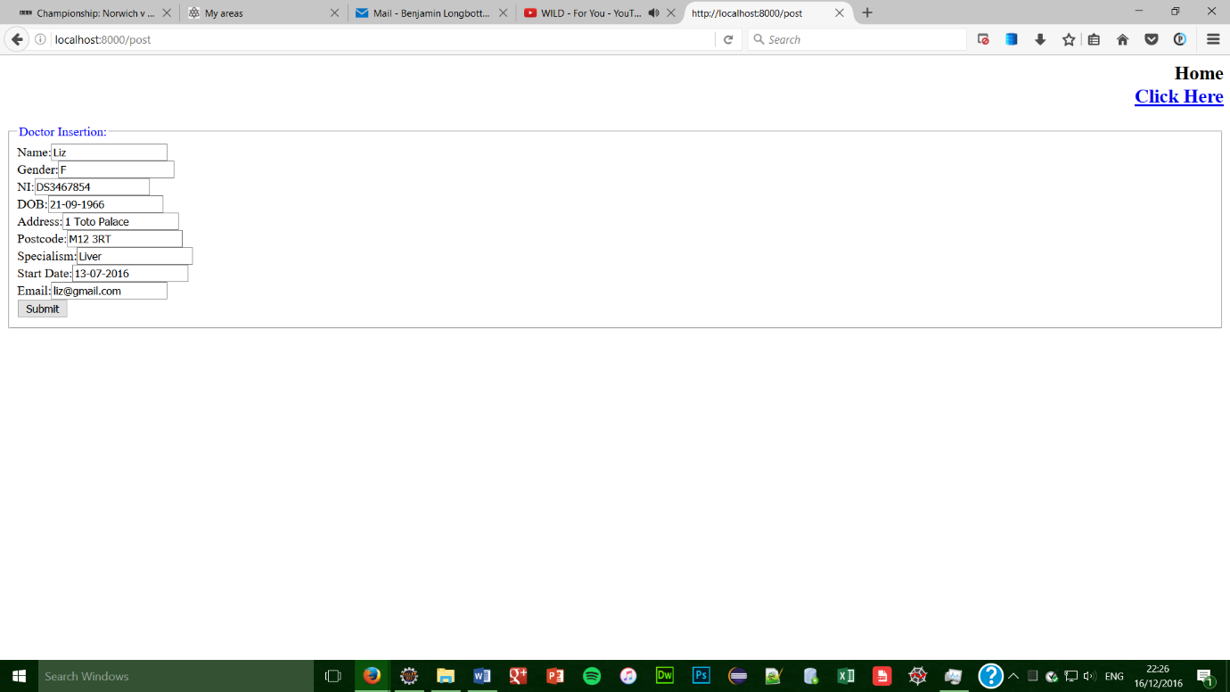localhost:8000/post – This page is accessed through the ‘Doctor Insertion’ button on the home page and adds a doctor to the database. (see below)

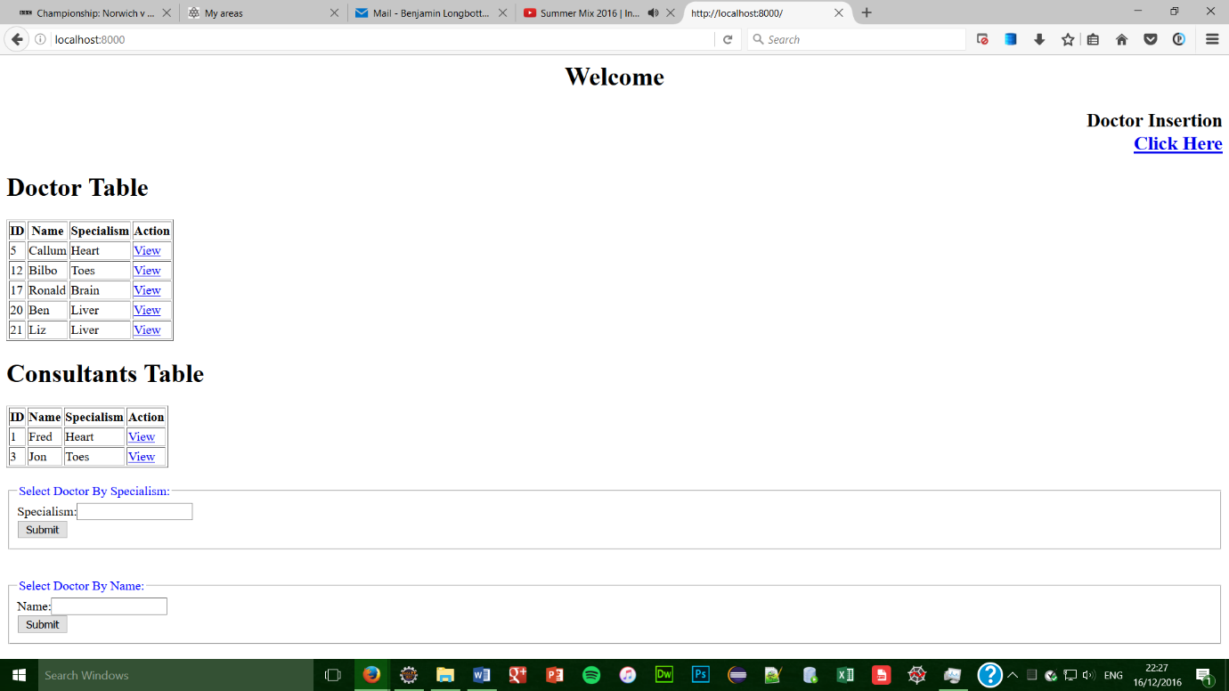

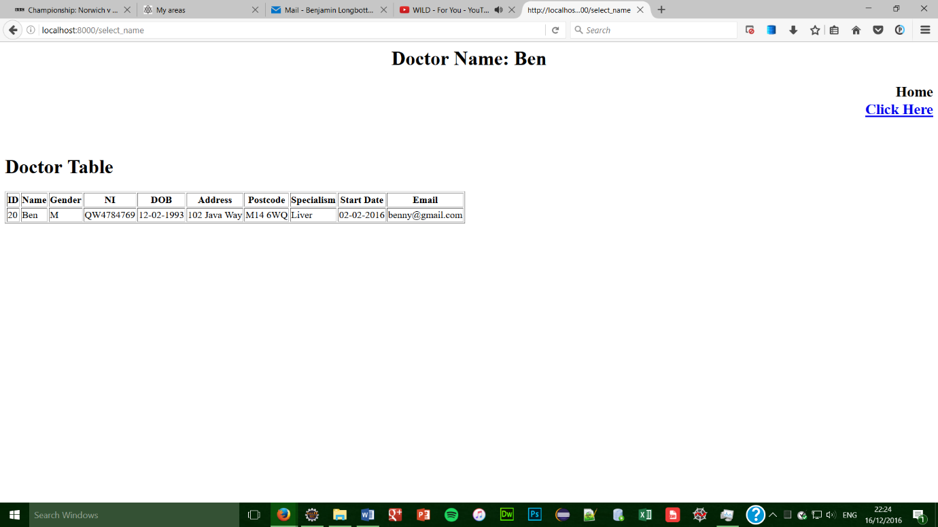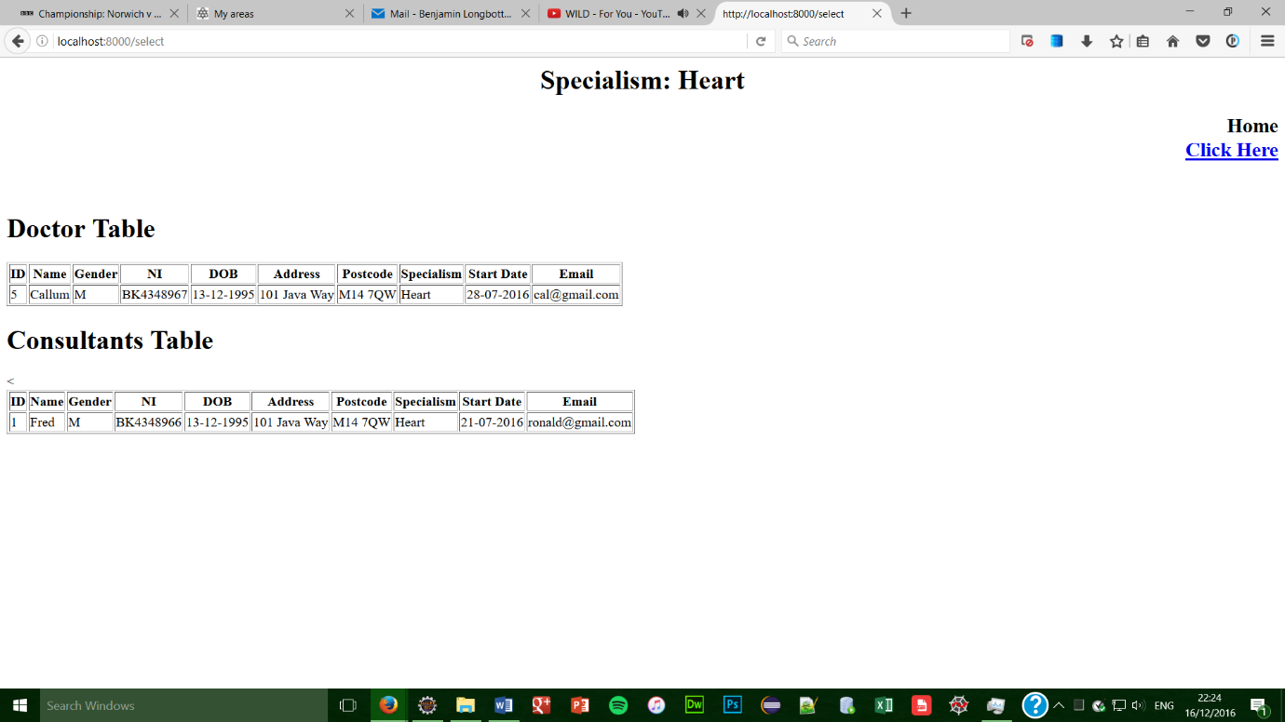localhost:8000/select – This page is accessed through the ‘specialism’ form on the home page and displays all consultants and doctors with the specialism entered. (see home page for entered specialism)

localhost:8000/select_name – This page is accessed through the ‘name’ form on the home page and displays all doctors with the name entered. (see home page for entered name)